Train Tool Architecture Overview
(updated 26.02.2007)

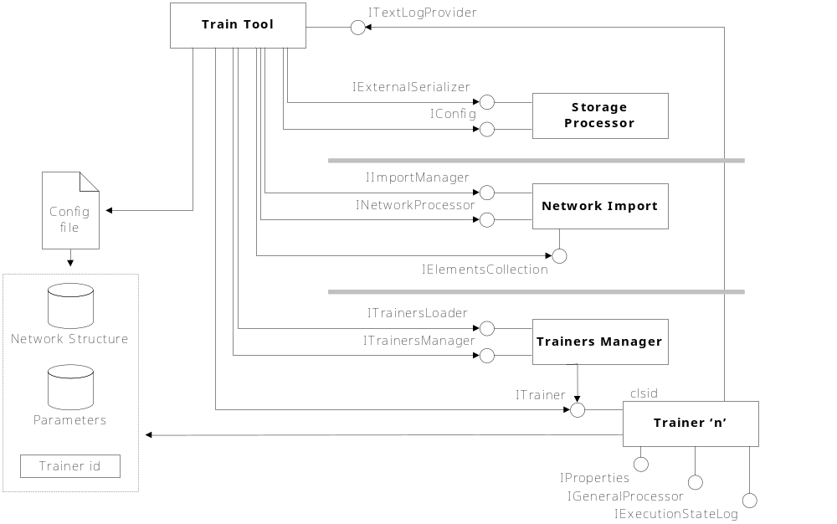

Допоненный формат файла конфигурации:

<?xml version="1.0" encoding="UTF-8" ?>
<Config version="1.0">
<NetworkProject niskdversion="1.1">
<Layer name="InputFactory" func="SingleChange" />
<Layer name="RBFLayer" func="Exponent" />
<Layer name="NeuronsLayer" func="Sigmoid" />
<Layer name="OutputFactory" func="SingleChange" />
</NetworkProject>
<Arguments>
<Argument name="InputVectorLength" value="400" />
<Argument name="ClassesCount" value="5" />
<Argument name="SamplesPerClass" value="10" />
<Argument name="WeightValue" value="2.0" />
</Arguments>
<Trainer clsid="{dddb35e4-ae9d-4196-8324-9ed619517b1b}" />
</Config>

